**Name:** Abenes, Enrico O. **Date:** November 13, 2023

**Subject & Section:** CC3, INTL A

**TRAVERSALS**

1. **Give the Graph (Tree) and the Traversal**
2. **Insert: 25, 27, 12, 5, 1, 7, 8, 9, 20, 29, 26**

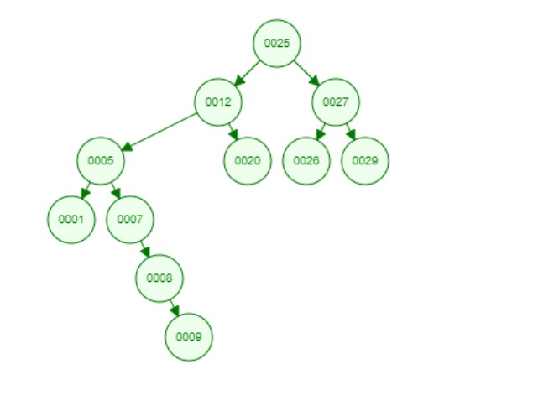

**Preorder: $25, 12, 5, 1, 7, 8, 9, 20, 27, 26, 29$**

**Inorder: $1, 5, 7, 8, 9, 12, 20, 25, 26, 27, 29$**

**Postorder: $1, 9, 8, 7, 5, 20, 12, 26, 29, 27, 25$**

1. **Insert: 16, 21, 29, 18, 12, 14, 17**

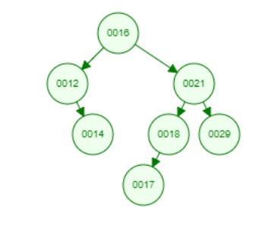

**Preorder: $16, 12, 14, 21, 18, 17, 29$**

**Inorder: $12, 14, 16, 17, 18, 21, 29$**

**Postorder: $14, 12, 17, 18, 29, 21, 16$**

1. **From the given traversal give the Graph (tree) and the missing traversal**

**Preorder: $29, 26, 6, 13, 32, 41, 35, 47$**

**Inorder: $6, 13, 26, 29, 32, 35, 41, 47$**

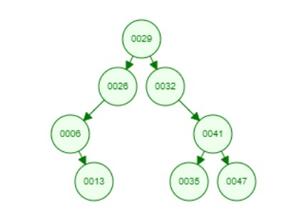

**Postorder: $13, 6, 26, 35, 47, 41, 32, 29$**